Read the following information quickly (scan it) to get the general idea. Then read the questions on the following pages. Go through this information in more detail in order to answer the questions.

The Life Cycles of Stars
A star’s life cycle is determined by its mass. The larger the mass, the shorter the life cycle. A star’s mass is determined by the amount of matter that is available in its nebula, the giant cloud of gas and dust in which it is born. Over time, gravity pulls the hydrogen gas in the nebula together and it begins to spin. As the gas spins faster and faster, it heats up and is known as a protostar. Eventually the temperature reaches 15,000,000 C and nuclear fusion occurs in the cloud’s core. The cloud begins to glow brightly. At this stage, it contracts a little and becomes stable. It is now called a main sequence star and will remain in this stage, shining for millions or billions of years to come.
As the main sequence star glows, hydrogen in the core is converted into helium by nuclear fusion. When the hydrogen supply in the core begins to run out, the core becomes unstable and contracts. The outer shell of the star, which is still mostly hydrogen, starts to expand. As it expands, it cools and glows red. The star has now reached the red giant phase. It is red because it is cooler than it was in the main sequence star stage and it is a giant because the outer shell has expanded outward. All stars evolve the same way up to the red giant phase. The amount of mass a star has determines which of the following life cycle paths it will take after the red giant phase.
MEDIUM STARS
Throughout the red giant phase, the hydrogen gas in the outer shell continues to burn and the temperature in the core continues to increase. At 200,000,000 C the helium atoms in the core fuse to form carbon atoms. The last of the hydrogen gas in the outer shell is blown away to form a ring around the core. This ring is called a planetary nebula. When the last of the helium atoms in the core are fused into carbon atoms, the medium size star begins to die. Gravity causes the last of the star’s matter to collapse inward and compact. This is the white dwarf stage. At this stage, the star’s matter is extremely dense. White dwarfs shine with a white hot light. Once all of their energy is gone, they no longer emit light. The star has now reached the black dwarf phase in which it will forever remain.
MASSIVE STARS
Once massive stars reach the red giant phase, the core temperature increases as carbon atoms are formed from the fusion of helium atoms. Gravity continues to pull carbon atoms together as the temperature increases forming oxygen, nitrogen, and eventually iron. At this point, fusion stops and the iron atoms start to absorb energy. This energy is eventually released in a powerful explosion called a supernova. A supernova can light up the sky for weeks. The temperature in a supernova can reach 1,000,000,000 C. The core of a massive star that is 1.5 to 4 times as massive as our Sun ends up as a neutron star after the supernova. Neutron stars spin rapidly giving off radio waves. If the radio waves are emitted in pulses (due to the star’s spin), these neutron stars are called pulsars. The core of a massive star that has 8 or more times the mass of our Sun remains massive after the supernova. No nuclear fusion is taking place to support the core, so it is swallowed by its own gravity. It has now become a black hole which readily attracts any matter and energy that comes near it. Black holes are not visible. They are detected by the X-rays which are given off as matter falls into the hole.

STAR LIFE - LEVEL 1
In the list below you will find the steps in the life cycle of a massive star. The steps are not in order. Carefully cut each step out with scissors. Using the information you have learned about massive stars, place the strips in the order in which they occur in a star’s life cycle.
- A supernova occurs.
- Nuclear fusion occurs which causes the star to glow.
- If it is a massive star, a neutron star forms. If it is a super massive star, a black hole forms.
- Gravity pulls hydrogen gas together to form a cloud.
- Iron, which acts as an energy sponge, forms within the star.
- A red giant forms when the star’s hydrogen level drops.
- A main sequence star, which can live for millions or even billions of years, forms.

SPACE CONNECTION - LEVEL 1
Draw a line to connect each word to the group of words that best describes it.
1. Star | - The medium size star in our solar system
2. Sun | - To shine brightly
3. Core | - A star that does not give off light
4. Glow | - A glowing ball of gas
5. Red Giant | - A giant explosion that took place in space a very long time ago
6. Expand | - The middle
7. Black Dwarf | - A large star that glows red
8. Big Bang | - To grow larger

By responding correctly (with a true or false) to the following sequence of statements you should be able to reach one of 5 end points. End point E means you have all T/F responses correct.

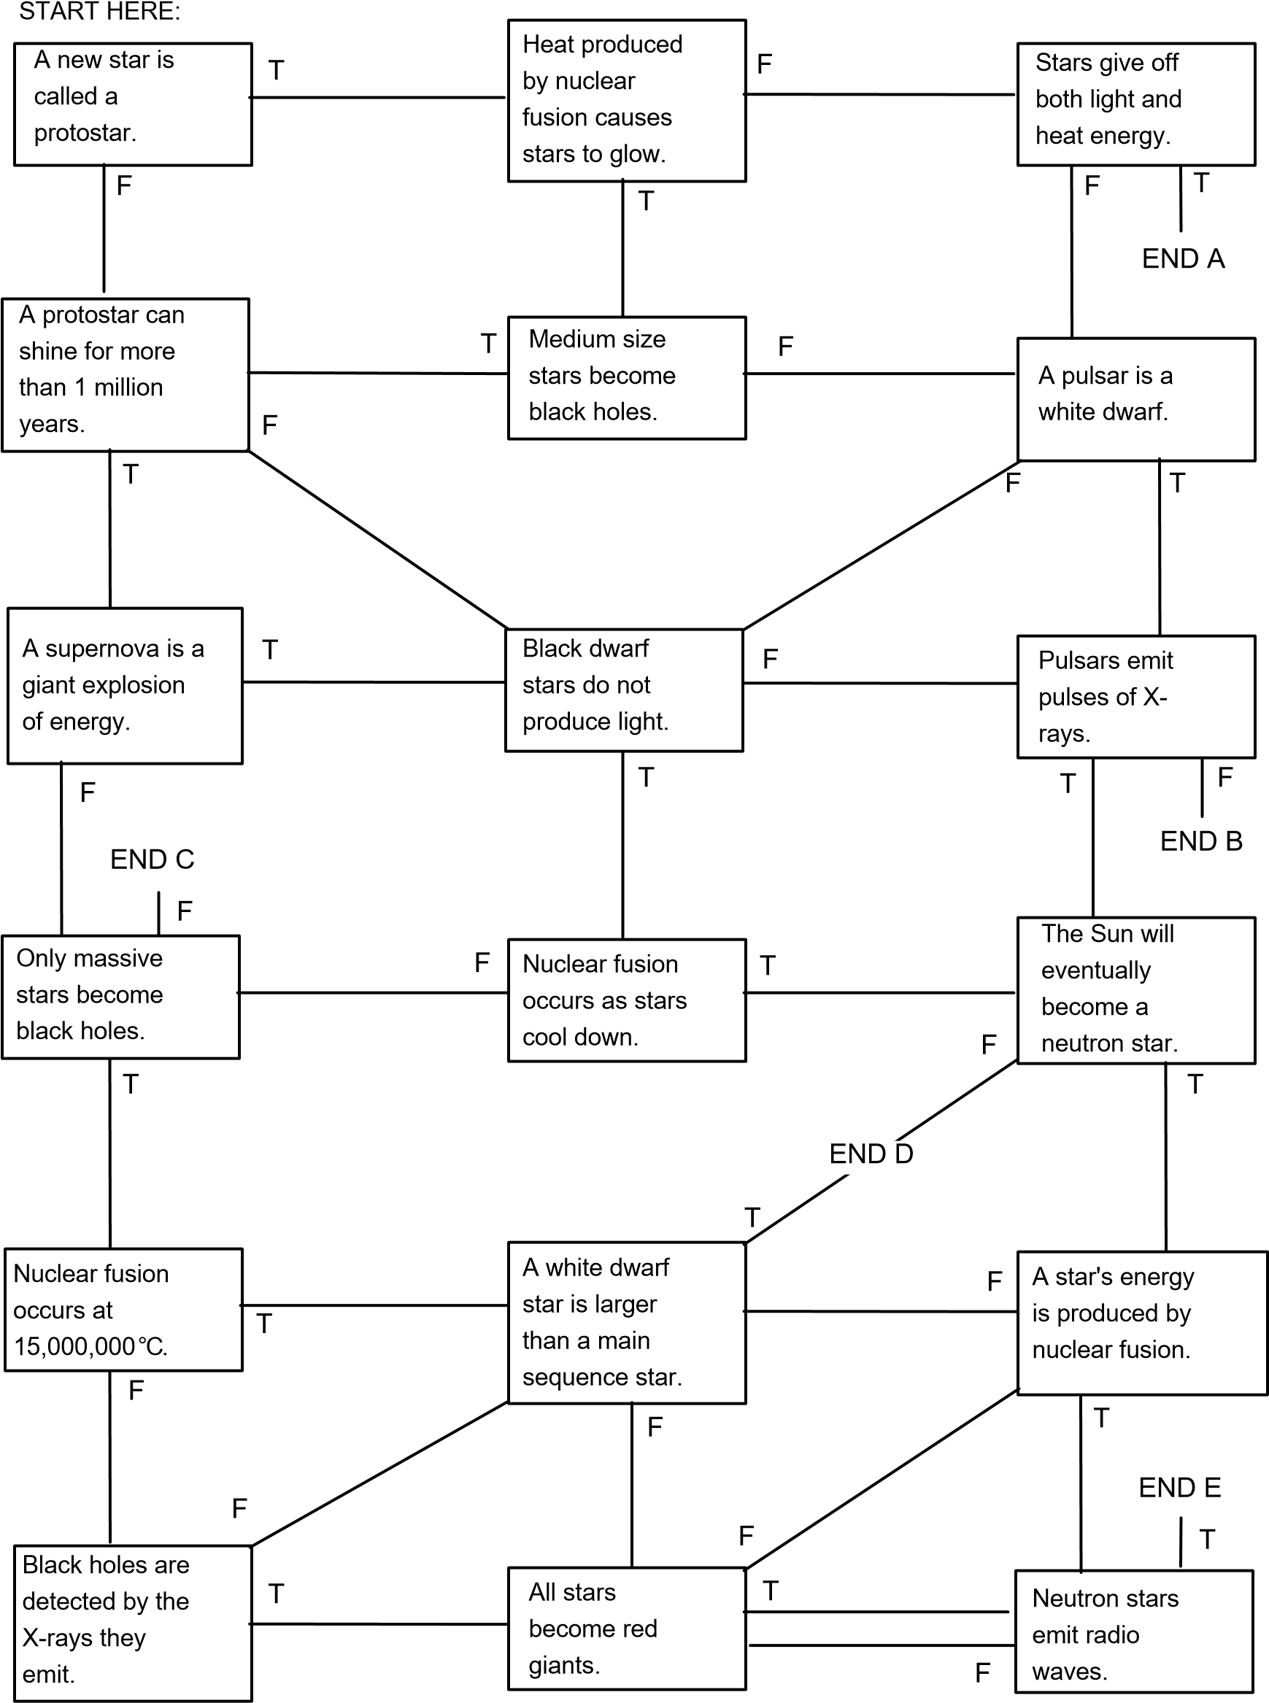
Main sequence stars run on Helium fusing to form Hydrogen

